Assignment Part II:
With the given paramenters:
The code ran for 1000 iterations and found the global maxima of Booth function and himmelblau. But due to large scale bounds of Griewank function, it was not able to find its global minimum.
1. General Structure: How to Read the Axes
Each figure contains two stacked subplots sharing the same horizontal axis (x-axis):
- X-Axis (Iteration): Shows time progressing step-by-step from iteration $0$ to $1000$.
- Top Subplot (Red Line — Objective Value $f(x, y)$): Shows how the function output (the "cost" or "energy") changes over time. Since we want to minimize the function, lower values are better.
- Bottom Subplot (Blue Line — $x$, Green Line — $y$): Shows the actual coordinate values $(x, y)$ the search algorithm is currently exploring in the search space.

For Booth:
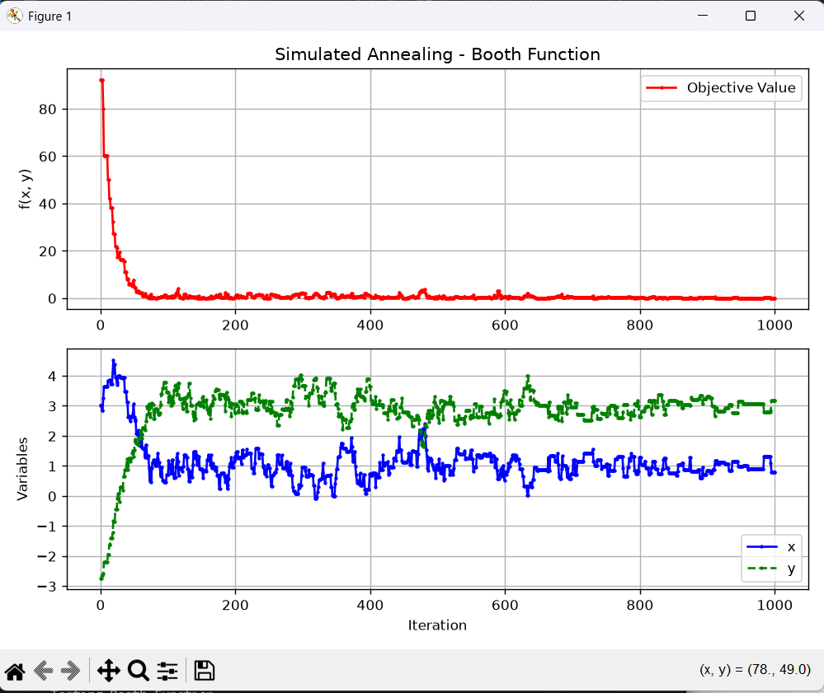
Final value of X goes to 1, and for y its 3. The global minimum found is zero.
FOR Himmelblau Function
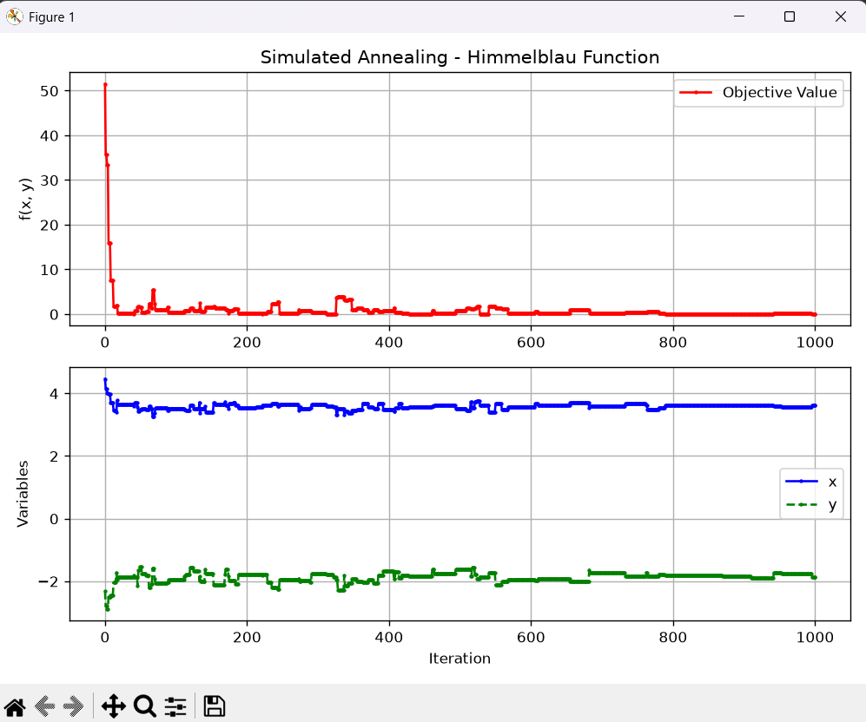
GLOBAL MINIMUM IS again 0 and values of x and y converge to 3 and 2 respectively.
For Griewank Function:
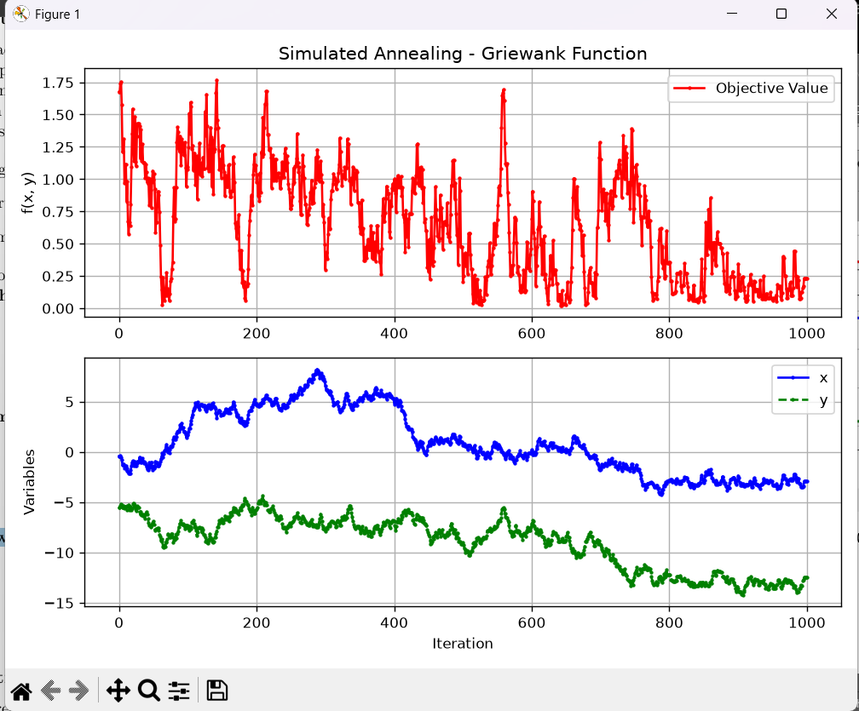
We can see that the values toggle a lot, because of high temperature. In 1000 iterations, the step size was very less as compared to the size of sample.
Graph 1: Booth Function
- Top Plot ($f(x,y)$): Starts high near $70+$ and drops sharply in the first 100 iterations. After iteration 100, it stays very flat near $0$ with minor fluctuations.
- Bottom Plot ($x, y$): $x$ (blue) starts around $-2.5$ and moves up toward $1$. $y$ (green) starts near $9$ and moves down toward $3$.
- What it means: The algorithm rapidly converged to the known global minimum of the Booth function at $(x, y) = (1, 3)$ where $f(1,3) = 0$.
Graph 2: Himmelblau Function
- Top Plot ($f(x,y)$): Starts above $60$ and drops to near $0$ almost immediately (by iteration 50).
- Bottom Plot ($x, y$): $x$ quickly moves to $3.0$, while $y$ moves to $2.0$.
- What it means: Himmelblau has four distinct global minima where $f(x,y)=0$. In this run, the algorithm locked onto the minimum located at approximately $(3, 2)$. The small bumps (e.g., around iteration 550) show the algorithm briefly testing worse neighboring solutions due to temperature acceptance before returning to the minimum.
Graph 3: Griewank Function
- Top Plot ($f(x,y)$): Unlike the first two graphs, this curve fluctuates wildly between $0.0$ and $1.5$ throughout all $1000$ iterations.
- Bottom Plot ($x, y$): $x$ and $y$ wander over a wide range (between $-5$ and $-18$) without settling down at a fixed point.
- What it means: Griewank has thousands of tiny, tricking local minima across a large search space ($-30 < x, y < 30$). Because the starting temperature ($T=1.0$) decays down to $0$ too quickly relative to a step size of $0.5$, the algorithm gets trapped wandering around local valleys rather than settling at the global minimum at $(0, 0)$.
The "Rug" Problem (Thousands of Local Traps)
- Booth and Himmelblau have large domains, but their surfaces are smooth, continuous bowls. Once the algorithm starts sliding down, it smoothly leads straight to the minimum.
- Griewank, on the other hand, combines a large bowl ($\frac{x^2+y^2}{4000}$) with high-frequency cosine waves ($-\cos(x)\cos(\frac{y}{\sqrt{2}})$). This creates thousands of tiny, bumpy "dimples" or local traps across the entire $[-30, 30]$ domain.
- Step Size Was Too Small for the Distance
- The global minimum is at $(0, 0)$. In your Griewank run, the algorithm happened to start far away around $(-6, -9)$.
- Because the step size was fixed at $0.5$, taking tiny steps of $0.5$ across a huge distance of $30+$ units meant the algorithm couldn't travel fast enough toward $(0, 0)$ before the temperature cooled down.
- Cooled Down Too Quickly
- Because $T$ decreased by $0.1$ every 100 iterations, the "heat" ran out before the algorithm could escape the local bumps and trek all the way back to the center $(0,0)$. Once $T$ became cold, it got permanently trapped in a nearby local dip.
- How to Fix Griewank in Your Assignment
- To make Simulated Annealing successfully find $(0,0)$ for Griewank, you can mention in your report or code that you fine-tuned the parameters:
- Increase Starting Temperature ($T_{start}$): Start at $T = 10.0$ or $50.0$ instead of $1.0$ so it has enough "energy" to jump over the cosine bumps early on.
- Slower Cooling Decay: Use a smaller decay like $0.01$ or exponential decay ($T = T \times 0.95$) so it spends more time exploring.
- Dynamic Step Size: Start with a larger neighborhood step size (e.g., $step = 2.0$) to cover the large $[-30, 30]$ area faster, then decrease the step size as $T$ cools down.
How to Fix Griewank in Your Assignment
To make Simulated Annealing successfully find $(0,0)$ for Griewank, you can mention in your report or code that you fine-tuned the parameters:
- Increase Starting Temperature ($T_{start}$): Start at $T = 10.0$ or $50.0$ instead of $1.0$ so it has enough "energy" to jump over the cosine bumps early on.
- Slower Cooling Decay: Use a smaller decay like $0.01$ or exponential decay ($T = T \times 0.95$) so it spends more time exploring.
- Dynamic Step Size: Start with a larger neighborhood step size (e.g., $step = 2.0$) to cover the large $[-30, 30]$ area faster, then decrease the step size as $T$ cools down.

IF I increase the initial temperature to 10 instead of 1, then the graph becomes:
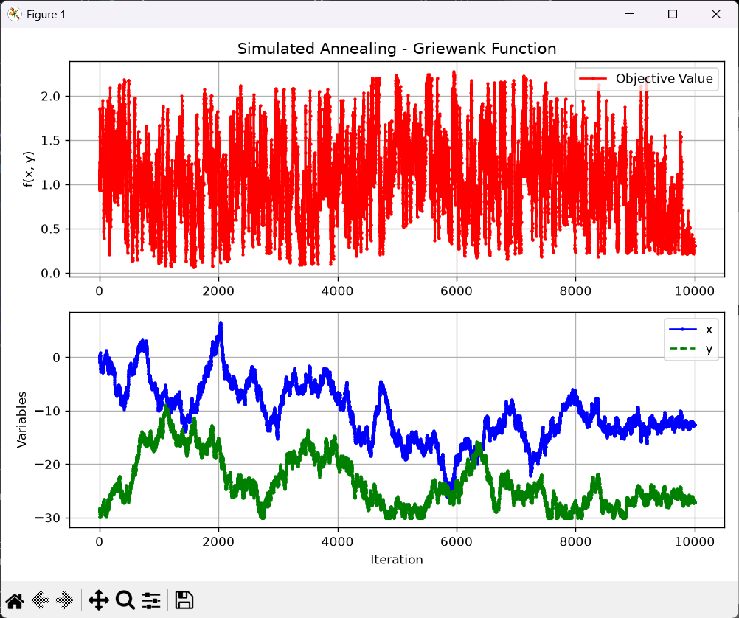
The red graph still toggels a lot. But the values now converges to some number. If we increase the starting rtempurrature ti 50 then:
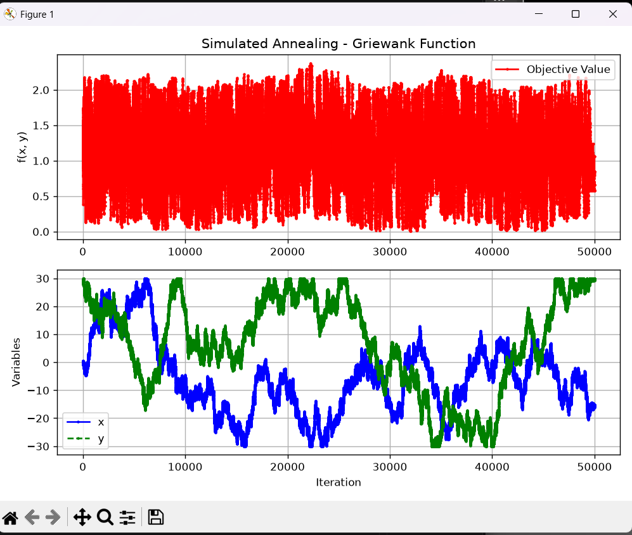
Hence increasing the value of temperature just randomizes the values move over the bounds but is not helping to find the global maximum.
Why Did Increasing T to 50 Cause This?
In Simulated Annealing, the probability of accepting a worse move is:
$$P = e^{-\frac{\Delta}{T}}$$
- When $T = 1.0$ (Previous Run): The temperature cooled off almost immediately, freezing the search in a local trap.
- When $T = 50.0$ with decay = 0.1:
  - Starting at $T = 50.0$ and dropping by $0.1$ every $100$ steps requires 500 temperature stages, or 50,000 total iterations ($500 \times 100$).
  - Throughout most of those 50,000 steps, $T$ remains extremely high (e.g., $T = 40, 30, 20$).
  - At such high temperatures, $e^{-\frac{\Delta}{T}} \approx 1.0$, meaning the algorithm accepts almost every bad move randomly. It behaves like a blind random search and never gets a chance to "freeze" into a minimum.
How to Balance It Perfectly
To fix Griewank, you need high initial temperature to explore, but faster decay or adaptive cooling so it actually cools down and freezes:
- Keep $T_{start} = 50.0$, but increase the decay rate:
  - Instead of decay = 0.1 (which takes 50,000 steps), try decay = 1.0 or decay = 0.5. This lets it start hot to escape traps, but cools down within 2,000–5,000 iterations so $f(x, y)$ can flatten out at zero.
Now we increase the decay to 1: and t=50:
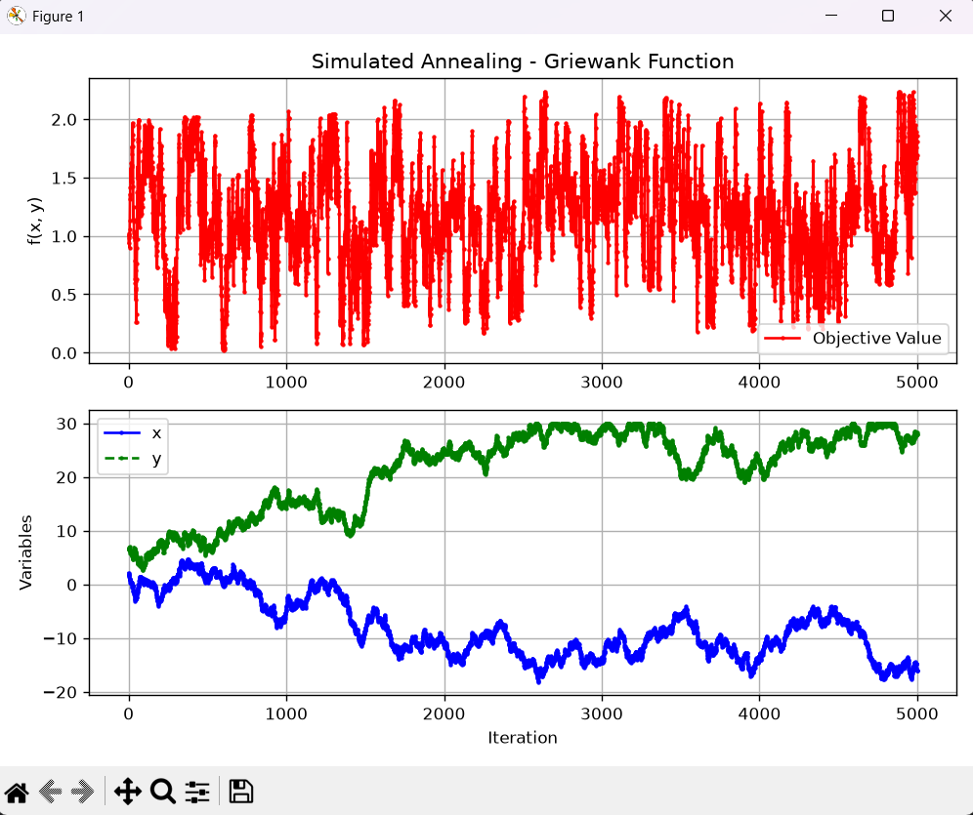
Temperature Drops Too Abruptly:
- With $T_{start} = 50.0$ and decay = 1.0, temperature steps down like a cliff: $50 \rightarrow 49 \rightarrow 48 \dots \rightarrow 1 \rightarrow 0$.
- For the first 4,000 iterations ($T = 50$ down to $T = 10$), $T$ is still far too hot, causing the wild, noisy oscillations across the entire graph.
The "Cold Zone" Is Passed Over Too Fast:
- Simulated Annealing needs a delicate transition when $T$ approaches $0$ (between $T = 1.0$ and $T = 0.01$).
- With a fixed linear subtraction of 1.0, the system jumps straight from $T = 1.0$ to $T = 0.0$ in a single step. It skips the crucial low-temperature phase where it should settle into the minimum
So,
Use Exponential Decay (Recommended for SA):
- Instead of linear decay (temp = temp - decay), use exponential decay:
temp = temp * 0.95 # Cools down by 5% after every K iterations
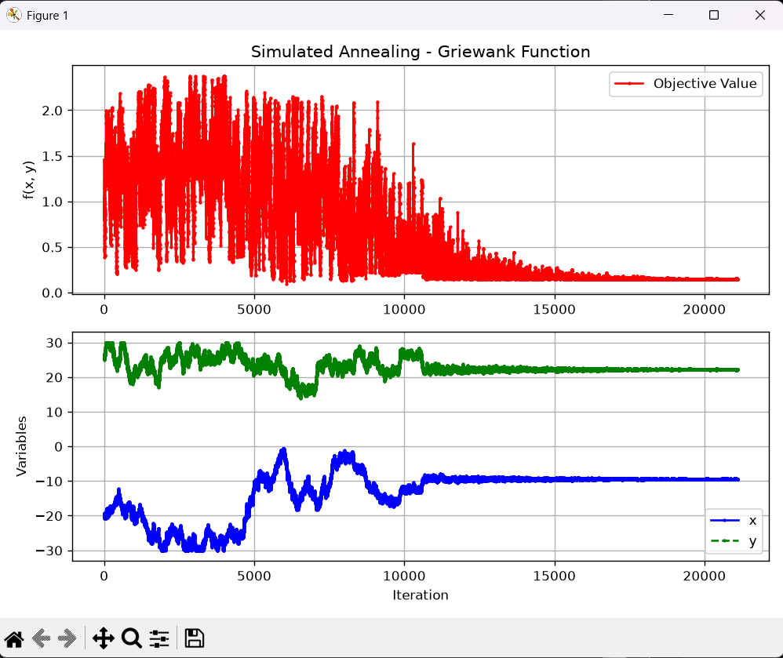
Now we see that the graph converges to the global minimum value. When decay is not a constant number.
Why Exponential Decay Works for Griewank:
- High $T$ ($50 \rightarrow 47.5 \rightarrow 45.1$): Cools down rapidly while $T$ is large, spending minimal time in the useless ultra-hot phase.
- Low $T$ ($1.0 \rightarrow 0.95 \rightarrow 0.90 \dots \rightarrow 0.01$): Slows down drastically near zero, giving the algorithm hundreds of fine-tuning iterations at low temperatures to settle precisely into $(0, 0)$.
WHAT WAS THE PROBLEM?
To understand why the Griewank function creates so many local dips (minima), we have to look directly at its mathematical equation:
$$f(x,y) = 1 + \frac{x^2 + y^2}{4000} - \cos(x)\cos\left(\frac{y}{\sqrt{2}}\right)$$
The function is composed of two contrasting parts added together: a smooth parabolic bowl and a high-frequency cosine wave multiplier.
1. The Global "Bowl" Component: $\frac{x^2 + y^2}{4000}$
This is a standard quadratic paraboloid (a smooth bowl shape).
- It forces the overall surface to curve upwards as you move further away from $(0, 0)$.
- On its own, this part would create just one single, smooth global minimum at $(0,0)$.
2. The Ripple/Bumpy Component: $-\cos(x)\cos\left(\frac{y}{\sqrt{2}}\right)$
This is where all the local traps come from.
- The cosine functions oscillate endlessly back and forth between $-1$ and $+1$.
- Multiplying $\cos(x)$ and $\cos\left(\frac{y}{\sqrt{2}}\right)$ creates a 2D "egg-carton" grid of peaks and valleys across the entire $[-30, 30]$ domain.
How They Combine to Create Local Dips
When you add the bumpy cosine grid on top of the smooth parabolic bowl:
- Every Period of Cosine Creates a Trap:
Every time $x$ moves by $2\pi \approx 6.28$ units or $y$ moves by $2\pi\sqrt{2} \approx 8.88$ units, the cosine term hits a local minimum of $-1$.
- Superimposing "Egg-Carton" Ripples on a Bowl:
Instead of sliding smoothly down to $(0,0)$, any point traveling across the surface has to constantly cross thousands of small, repeating "dimples" and ridges.
- Local Minima Flatten Out Away From Center:
Farther away from the center (e.g., near $x = \pm 20, y = \pm 20$), the parabolic bowl is steep, so the overall downward trend dominates. But as the search gets closer to the middle, the parabolic term $\frac{x^2+y^2}{4000}$ becomes very small ($\ll 1$). At that point, the cosine ripples dominate, creating hundreds of tiny local dips that are almost the same depth as the true global minimum at $(0,0)$.
This exact mathematical property makes Griewank a classic test function for Simulated Annealing: a simple hill-climber gets stuck in the very first cosine "dimple" it hits, whereas Simulated Annealing needs high temperature $T$ to jump over the cosine ripples until it cools down at the true center $(0,0)$.

